EWMA correlation: GBPUSD and EURGBP
Method 06 / daily log returns / lambda = 0.94 / Alpari D1 full available history

Study setup
Logical pair: GBPUSD , EURGBP
Broker symbols: GBPUSD_i , EURGBP_i
Snapshot: 2026-11-03_majors_alpari_D1
Timeframe: D1
Matched return window: 1999-01-06 to 2026-11-02 (UTC bar dates)
Matched return count n: 7199
Dropped unfinished last bar dated 2026-11-03 UTC after a tick-volume check against the prior complete day.
Lambda: 0.94 (today weight 0.06)
Burn-in ignored in path summaries and chart: first 60 updates
Mean adjustment: each leg demeaned by its mean on the matched rows
Seeds: c_0 = v_x,0 = v_y,0 = 0
Complete matched rows (Excel): GBPUSD-EURGBP_EWMA_D1.xlsx
Complete matched rows (HTML table): GBPUSD-EURGBP_EWMA_D1_data.html

Method carried forward
EWMA correlation updates covariance and variances of mean-adjusted daily log returns of close, ln(close_t / close_t-1), with lambda = 0.94 (6% weight on today's product or square, 94% on yesterday's EWMA state). Quotes are not inverted. Each leg is demeaned by its mean on the matched rows; that mean uses the full sample, so the rho path is a full-sample description, not a live filter. Seeds start at zero. Path summaries and the chart ignore the first 60 updates so the zero seed has faded. The headline is rho on the last day. rho is symmetric under swap of the two symbols. A high |rho| does not prove cause, lead-lag, or a trading signal. Today's return sits inside today's rho, so the estimate can only inform a later decision. Same-sample Pearson r is a side check only.

Results
Latest EWMA rho: -0.353983
Post-burn-in path (n=7139): mean=-0.355678, median=-0.366990, min=-0.963861, max=0.519124, std=0.277733
Share of post-burn-in days with |rho| >= 0.4: 45.86%; |rho| >= 0.7: 11.98%
Same-sample Pearson r: -0.397845
Latest rho minus r: 0.043863

Conclusion
Over 7199 matched daily log-return rows for GBPUSD and EURGBP (broker quote directions unchanged), latest EWMA rho with lambda=0.94 is -0.3540 (negative, weak recent linear link in this sample). After a 60-day burn-in, path mean is -0.3557, std is 0.2777, and the range is [-0.9639, 0.5191]. Same-sample Pearson r is -0.3978 (latest rho minus r = 0.0439). This does not establish cause, lead-lag, or a lasting trading rule.

Charts
Daily closes

Daily log returns
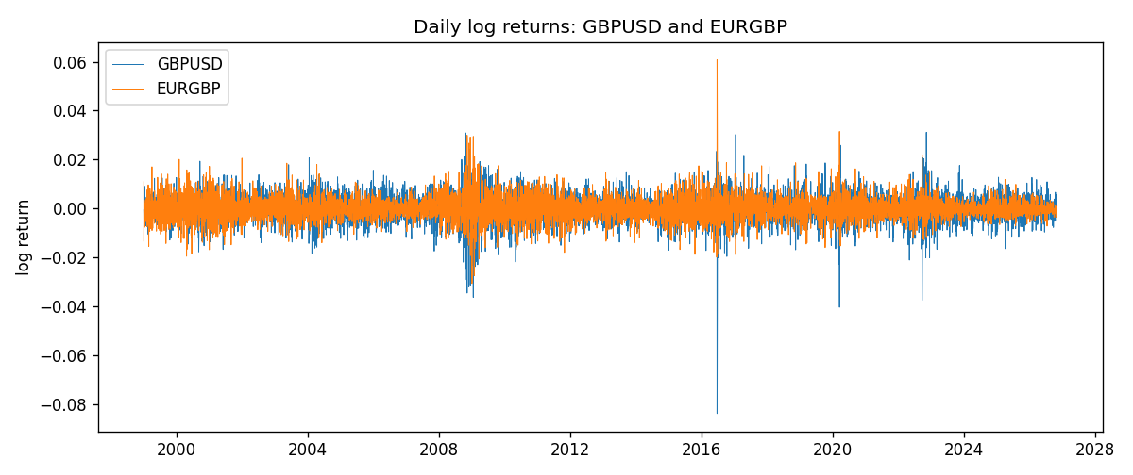
EWMA rho path with Pearson r reference
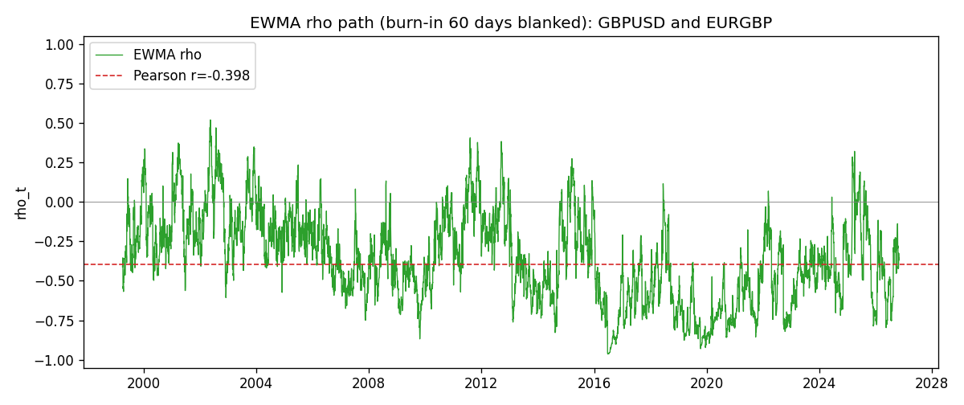

Data report
Every matched row that entered the EWMA recursion is stored in the sibling Excel workbook named GBPUSD-EURGBP_EWMA_D1.xlsx. That file is the complete data archive for redrawing charts. Embedding all rows as a Word table is impractical at this length; the Word file holds the column list, column summaries, and the first and last 15 matched rows.
Columns: time, GBPUSD_open, EURGBP_open, GBPUSD_high, EURGBP_high, GBPUSD_low, EURGBP_low, GBPUSD_close, EURGBP_close, GBPUSD_tick_volume, EURGBP_tick_volume, GBPUSD_spread, EURGBP_spread, GBPUSD_real_volume, EURGBP_real_volume, GBPUSD_log_return, EURGBP_log_return, GBPUSD_x_demeaned, EURGBP_y_demeaned, c_t, v_x, v_y, rho_t
Column summaries (matched calculation rows)
column | count | mean | std | min | 25% | 50% | 75% | max
GBPUSD_open | 7199 | 1.5160931 | 0.21831499 | 1.06854 | 1.324955 | 1.5114 | 1.63186 | 2.1066
EURGBP_open | 7199 | 0.78665041 | 0.09676322 | 0.5734 | 0.6873 | 0.83367 | 0.865175 | 0.9769
GBPUSD_high | 7199 | 1.5223838 | 0.21887686 | 1.08366 | 1.32978 | 1.5181 | 1.6384 | 2.1161
EURGBP_high | 7199 | 0.78972718 | 0.09713886 | 0.5789 | 0.68935 | 0.83657 | 0.86804 | 0.9799
GBPUSD_low | 7199 | 1.5097628 | 0.21753729 | 1.03518 | 1.3194 | 1.50323 | 1.62442 | 2.0983
EURGBP_low | 7199 | 0.78395066 | 0.09658082 | 0.5682 | 0.6853 | 0.83147 | 0.862765 | 0.9661
GBPUSD_close | 7199 | 1.5161471 | 0.21826306 | 1.06879 | 1.325055 | 1.51122 | 1.63216 | 2.1065
EURGBP_close | 7199 | 0.78669405 | 0.09676312 | 0.5735 | 0.6875 | 0.8337 | 0.86528 | 0.977
GBPUSD_tick_volume | 7199 | 94850.986 | 153561.38 | 62 | 9998.5 | 52911 | 91818.5 | 1273370
EURGBP_tick_volume | 7199 | 86949.029 | 145390.09 | 154 | 6517.5 | 44265 | 81326 | 1424684
GBPUSD_spread | 7199 | 26.96055 | 19.19062 | 0 | 11 | 20 | 50 | 50
EURGBP_spread | 7199 | 21.393666 | 19.14328 | 0 | 4 | 13 | 50 | 50
GBPUSD_real_volume | 7199 | 3.5570778e+09 | 8.4449923e+10 | 0 | 0 | 0 | 0 | 2.4038164e+12
EURGBP_real_volume | 7199 | 2.7805214e+10 | 1.3507095e+11 | 0 | 0 | 0 | 0 | 3.5726265e+12
GBPUSD_log_return | 7199 | -3.133e-05 | 0.00564236 | -0.08388241 | -0.00313644 | 2.978e-05 | 0.00317207 | 0.03112653
EURGBP_log_return | 7199 | 2.179e-05 | 0.00487166 | -0.03067367 | -0.0026225 | -0.00010035 | 0.00256076 | 0.06075387
GBPUSD_x_demeaned | 7199 | 0 | 0.00564236 | -0.08385108 | -0.00310512 | 6.111e-05 | 0.00320339 | 0.03115786
EURGBP_y_demeaned | 7199 | -0 | 0.00487166 | -0.03069546 | -0.00264428 | -0.00012213 | 0.00253897 | 0.06073208
c_t | 7199 | -1.093e-05 | 2.096e-05 | -0.00037843 | -1.275e-05 | -5.96e-06 | -2.59e-06 | 1.328e-05
v_x | 7199 | 3.181e-05 | 3.404e-05 | 2e-08 | 1.75e-05 | 2.378e-05 | 3.334e-05 | 0.00052537
v_y | 7199 | 2.372e-05 | 2.334e-05 | 1.89e-06 | 1.053e-05 | 1.824e-05 | 3.01e-05 | 0.00029342
rho_t | 7199 | -0.35353348 | 0.27855682 | -0.96386063 | -0.55807609 | -0.36505278 | -0.16781758 | 1
First 15 matched rows (selected columns)
time | GBPUSD_close | EURGBP_close | GBPUSD_log_return | EURGBP_log_return | GBPUSD_x_demeaned | EURGBP_y_demeaned | c_t | v_x | v_y | rho_t
1999-01-06 | 1.6537 | 0.7019 | -0.00060452184 | -0.013303338 | -0.00057319278 | -0.013325123 | 4.5827186e-07 | 1.9712998e-08 | 1.0653534e-05 | 1
1999-01-07 | 1.6502 | 0.7097 | -0.002118709 | 0.011051402 | -0.0020873799 | 0.011029617 | -9.5060448e-07 | 2.7995951e-07 | 1.7313469e-05 | -0.43177768
1999-01-08 | 1.6405 | 0.7062 | -0.0058954193 | -0.004943862 | -0.0058640902 | -0.0049656472 | 8.5357196e-07 | 2.3264152e-06 | 1.775412e-05 | 0.13281495
1999-01-11 | 1.6312 | 0.7053 | -0.0056851331 | -0.0012752393 | -0.0056538041 | -0.0012970244 | 1.242345e-06 | 4.1047603e-06 | 1.6789809e-05 | 0.14964955
1999-01-12 | 1.6349 | 0.7077 | 0.0022657001 | 0.0033970309 | 0.0022970292 | 0.0033752458 | 1.6329865e-06 | 4.1750553e-06 | 1.6465958e-05 | 0.19695091
1999-01-13 | 1.6499 | 0.708 | 0.0091330396 | 0.00042381861 | 0.0091643687 | 0.0004020335 | 1.7560703e-06 | 8.9636911e-06 | 1.5487698e-05 | 0.14904075
1999-01-14 | 1.6531 | 0.7066 | 0.0019376331 | -0.0019793588 | 0.0019689621 | -0.0020011439 | 1.4142955e-06 | 8.6584784e-06 | 1.4798711e-05 | 0.12494171
1999-01-15 | 1.6502 | 0.7012 | -0.0017558204 | -0.0076715819 | -0.0017244913 | -0.007693367 | 2.1254665e-06 | 8.3174019e-06 | 1.7462062e-05 | 0.1763651
1999-01-18 | 1.6522 | 0.7017 | 0.0012112405 | 0.00071280921 | 0.0012425695 | 0.0006910241 | 2.0494572e-06 | 7.9109965e-06 | 1.6442989e-05 | 0.17969371
1999-01-19 | 1.6553 | 0.7007 | 0.0018745281 | -0.0014261269 | 0.0019058572 | -0.001447912 | 1.760919e-06 | 7.6542742e-06 | 1.5582197e-05 | 0.16124009
1999-01-20 | 1.6472 | 0.7021 | -0.0049053846 | 0.0019960086 | -0.0048740555 | 0.0019742235 | 1.0779153e-06 | 8.6204028e-06 | 1.4881118e-05 | 0.095170661
1999-01-21 | 1.6524 | 0.7016 | 0.0031518998 | -0.00071240297 | 0.0031832289 | -0.00073418808 | 8.7301509e-07 | 8.7111554e-06 | 1.4020593e-05 | 0.078995195
1999-01-22 | 1.6565 | 0.7004 | 0.0024781662 | -0.0017118406 | 0.0025094953 | -0.0017336258 | 5.5960264e-07 | 8.5663401e-06 | 1.3359685e-05 | 0.052309912
1999-01-25 | 1.6585 | 0.6966 | 0.0012066366 | -0.0054402425 | 0.0012379657 | -0.0054620276 | 1.2031831e-07 | 8.1443132e-06 | 1.4348129e-05 | 0.0111303
1999-01-26 | 1.6597 | 0.6962 | 0.00072328374 | -0.00057438255 | 0.0007546128 | -0.00059616767 | 8.6106665e-08 | 7.6898208e-06 | 1.3508566e-05 | 0.0084483916
Last 15 matched rows (selected columns)
time | GBPUSD_close | EURGBP_close | GBPUSD_log_return | EURGBP_log_return | GBPUSD_x_demeaned | EURGBP_y_demeaned | c_t | v_x | v_y | rho_t
2026-10-13 | 1.32534 | 0.84458 | 0.0036434319 | 0.00020130374 | 0.0036747609 | 0.00017951862 | -6.9563169e-07 | 9.4636899e-06 | 2.6750033e-06 | -0.13825694
2026-10-14 | 1.31884 | 0.84553 | -0.0049164679 | 0.0011241873 | -0.0048851389 | 0.0011024022 | -9.7701705e-07 | 1.0327743e-05 | 2.5874205e-06 | -0.18900179
2026-10-15 | 1.32757 | 0.84479 | 0.0065976411 | -0.00087557391 | 0.0066289701 | -0.00089735903 | -1.27531e-06 | 1.2344674e-05 | 2.4804905e-06 | -0.23046617
2026-10-16 | 1.33257 | 0.84307 | 0.0037592051 | -0.0020380844 | 0.0037905341 | -0.0020598695 | -1.6672718e-06 | 1.2466082e-05 | 2.5862448e-06 | -0.29363417
2026-10-19 | 1.33024 | 0.84259 | -0.0017500314 | -0.00056950988 | -0.0017187024 | -0.000591295 | -1.5062598e-06 | 1.1895353e-05 | 2.4520479e-06 | -0.27889887
2026-10-20 | 1.3377 | 0.83957 | 0.0055923442 | -0.0035906254 | 0.0056236733 | -0.0036124106 | -2.6347853e-06 | 1.3079174e-05 | 3.0878956e-06 | -0.41459471
2026-10-21 | 1.33937 | 0.83839 | 0.0012476328 | -0.00140647 | 0.0012789619 | -0.0014282551 | -2.5862992e-06 | 1.2392568e-05 | 3.0250166e-06 | -0.42241002
2026-10-22 | 1.33967 | 0.83682 | 0.00022396082 | -0.0018743924 | 0.00025528989 | -0.0018961775 | -2.4601657e-06 | 1.1652925e-05 | 3.059245e-06 | -0.41204037
2026-10-23 | 1.33684 | 0.83751 | -0.0021146949 | 0.00082421033 | -0.0020833659 | 0.00080242521 | -2.4128605e-06 | 1.1214174e-05 | 2.9143235e-06 | -0.42206534
2026-10-26 | 1.33359 | 0.83762 | -0.0024340661 | 0.00013133309 | -0.0024027371 | 0.00010954797 | -2.2838818e-06 | 1.0887712e-05 | 2.7401841e-06 | -0.41813395
2026-10-27 | 1.33044 | 0.83595 | -0.0023648393 | -0.0019957343 | -0.0023335103 | -0.0020175194 | -1.8643747e-06 | 1.0561166e-05 | 2.8199961e-06 | -0.34162765
2026-10-28 | 1.33254 | 0.83651 | 0.0015771808 | 0.00066967224 | 0.0016085098 | 0.00064788713 | -1.6899843e-06 | 1.0082734e-05 | 2.6759818e-06 | -0.32535083
2026-10-29 | 1.33733 | 0.83553 | 0.0035881935 | -0.0011722209 | 0.0036195226 | -0.001194006 | -1.8478891e-06 | 1.0263827e-05 | 2.600962e-06 | -0.35764673
2026-10-30 | 1.33913 | 0.83351 | 0.0013450605 | -0.0024205543 | 0.0013763895 | -0.0024423394 | -1.9387124e-06 | 9.7616639e-06 | 2.8028056e-06 | -0.37064229
2026-11-02 | 1.3406 | 0.83426 | 0.0010971256 | 0.00089940465 | 0.0011284546 | 0.00087761954 | -1.7629684e-06 | 9.2523687e-06 | 2.6808502e-06 | -0.3539825

